$\sin{= \frac{opposite}{hypothenuse}}$ , W = mg, f_{s} = µ_{s} N, f_{k} = µ_{k} N, F_{net}= ma
$\cos{= \frac{adjancent}{hypothenuse}}$ ,
$\tan{= \frac{opposite}{adjancent}}$
sin 2θ = 2 sinθ cosθ
(sinθ)² + (cosθ)² = 1
$$v{= \frac{Δx}{Δt}}$$
$$a{= \frac{Δv}{Δt}}$$
$$g{= 9.81m/s^2}$$
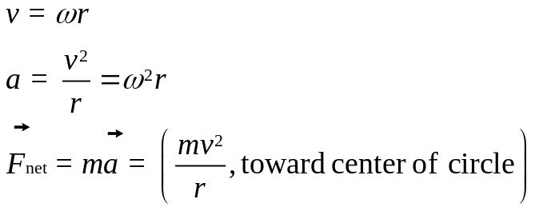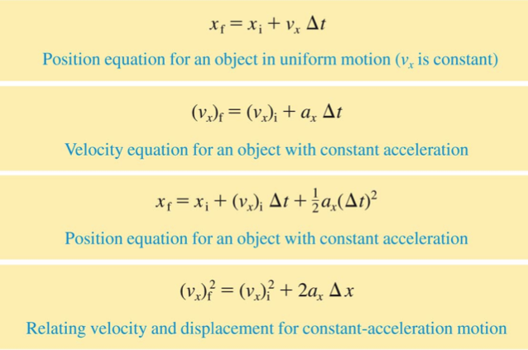

$$g_{planet}=\frac{GM_{planet}}{R_{planet}^{2}}$$
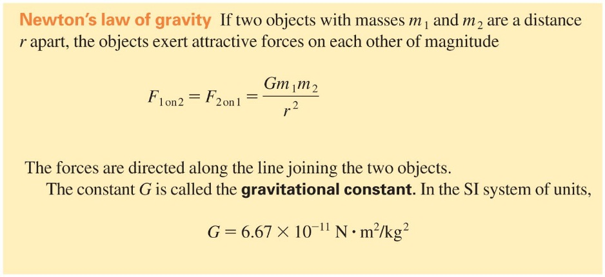

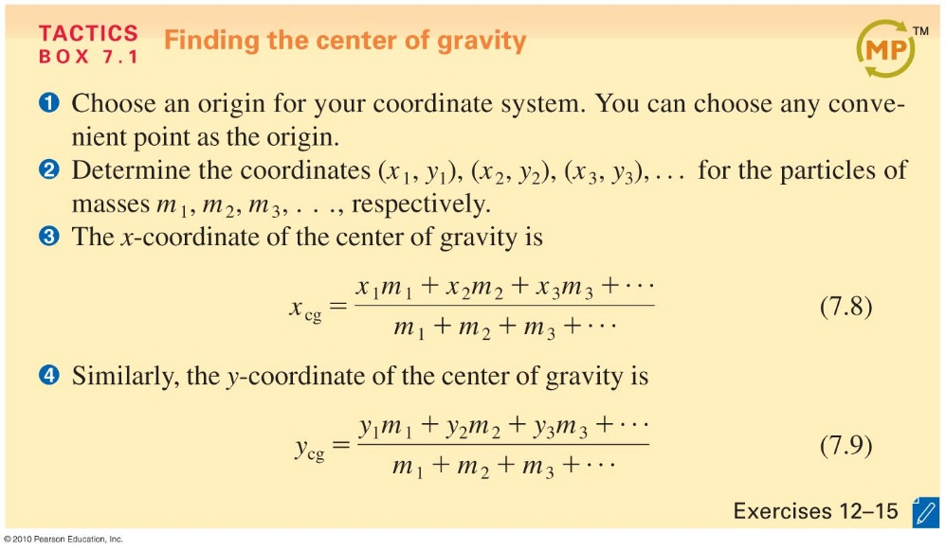

(F_{sp})_{x} = –k ∆x
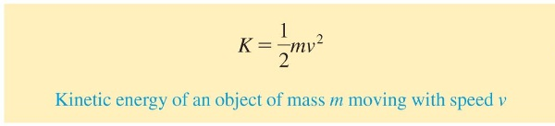

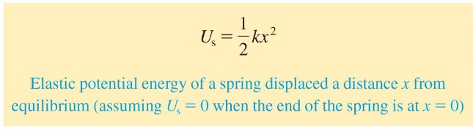

∆ K = W_{net} E_{i} =E_{f}




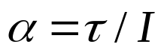
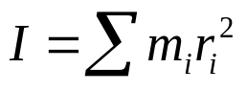


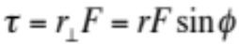

$\vec{τ_{net}}=$ $\frac{\vec{ΔL}}{Δt}$, L =Iω

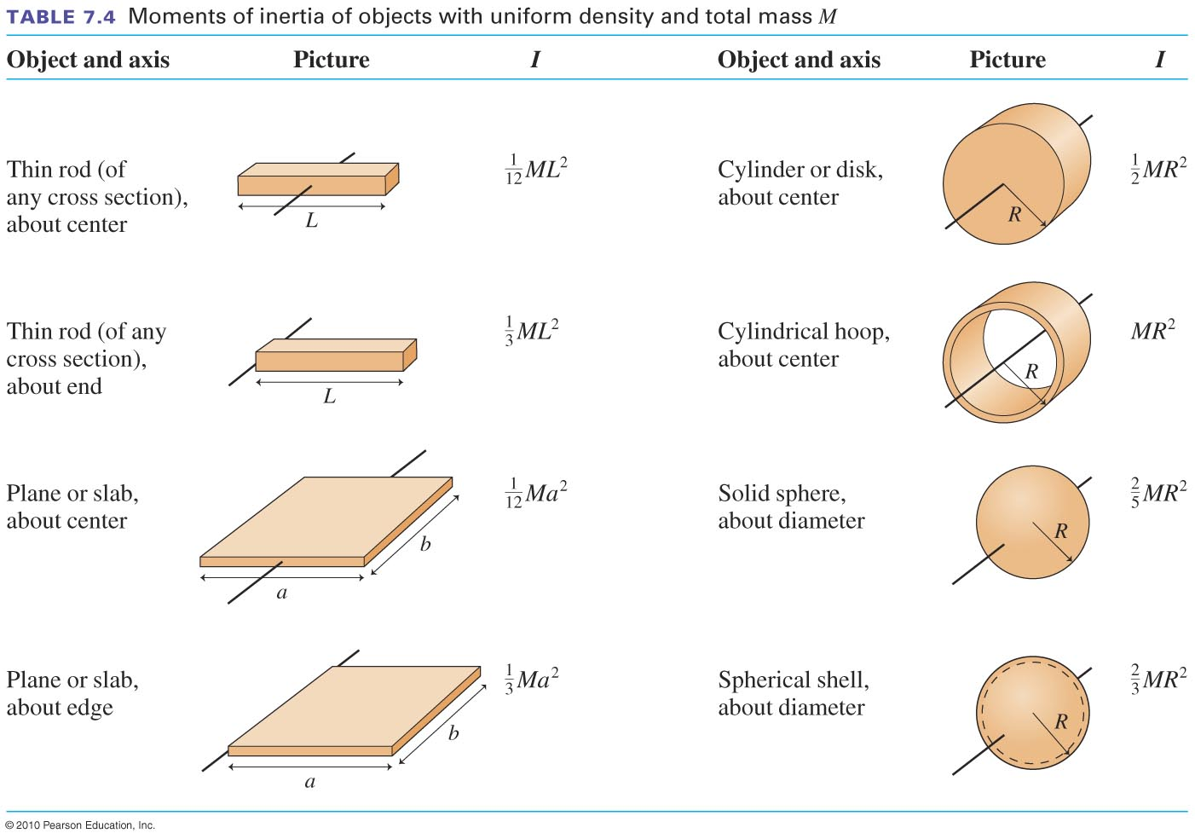
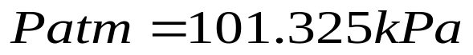
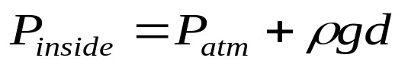
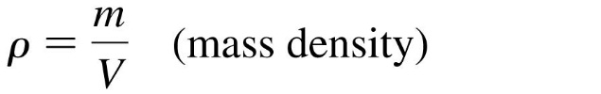
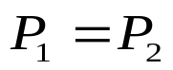
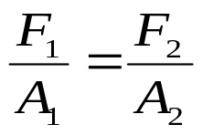

Continuity Equation: v₁A₁ = v₂A₂
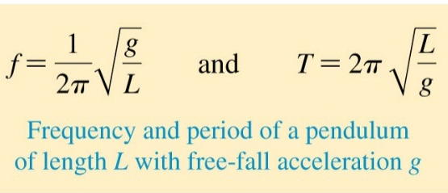


v = λ/T= λf $v=\sqrt{\frac{T}{μ}}$ k= 2π/λ
$I= \frac{P}{4πr^{2}}$ $β=10log\frac{I}{I_{0}}$
$$λ_{n}= \frac{2L}{n}$$

